**Blinkit Analysis(SQL Report)**

SELECT * FROM blinkit_data

* **DATA CLEANING:**

UPDATE blinkit_data

SET Item_Fat_Content =

CASE

WHEN Item_Fat_Content IN ('LF', 'low fat') THEN 'Low Fat'

WHEN Item_Fat_Content = 'reg' THEN 'Regular'

ELSE Item_Fat_Content

END;

**A. Clean Data Checking**

SELECT DISTINCT Item_Fat_Content FROM blinkit_data;

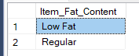

**A. KPI’s**

**1. TOTAL SALES:**

SELECT CAST(SUM(Total_Sales) / 1000000.0 AS DECIMAL(10,2)) AS Total_Sales_Million

FROM blinkit_data;

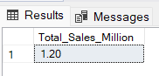

**2. AVERAGE SALES**

SELECT CAST(AVG(Total_Sales) AS INT) AS Avg_Sales

FROM blinkit_data;

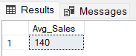

**3. NO OF ITEMS**

SELECT COUNT(*) AS No_of_Orders

FROM blinkit_data;

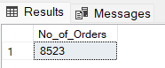

**4. AVG RATING**

SELECT CAST(AVG(Rating) AS DECIMAL(10,1)) AS Avg_Rating

FROM blinkit_data;

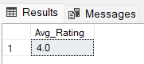

**B. Total Sales by Fat Content:**

SELECT Item_Fat_Content, CAST(SUM(Total_Sales) AS DECIMAL(10,2)) AS Total_Sales

FROM blinkit_data

GROUP BY Item_Fat_Content

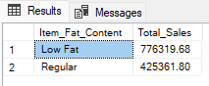

**C. Total Sales by Item Type**

SELECT Item_Type, CAST(SUM(Total_Sales) AS DECIMAL(10,2)) AS Total_Sales

FROM blinkit_data

GROUP BY Item_Type

ORDER BY Total_Sales DESC

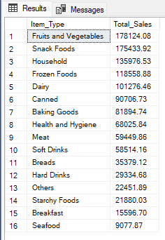

**D. Fat Content by Outlet for Total Sales**

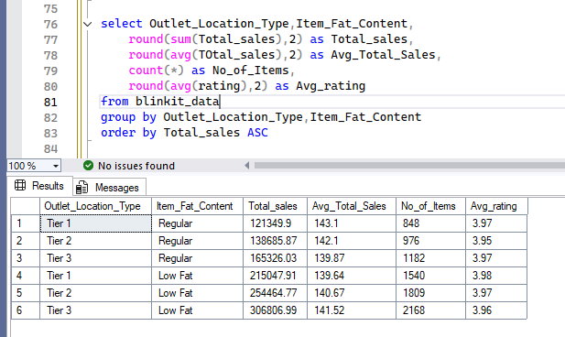

**E. Total Sales by Outlet Establishment**

SELECT Outlet_Establishment_Year, CAST(SUM(Total_Sales) AS DECIMAL(10,2)) AS Total_Sales

FROM blinkit_data

GROUP BY Outlet_Establishment_Year

ORDER BY Outlet_Establishment_Year

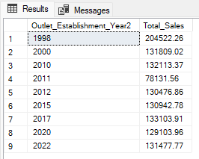

**F. Percentage of Sales by Outlet Size**

SELECT

Outlet_Size,

CAST(SUM(Total_Sales) AS DECIMAL(10,2)) AS Total_Sales,

CAST((SUM(Total_Sales) * 100.0 / SUM(SUM(Total_Sales)) OVER()) AS DECIMAL(10,2)) AS Sales_Percentage

FROM blinkit_data

GROUP BY Outlet_Size

ORDER BY Total_Sales DESC;

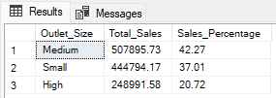

**G. Sales by Outlet Location**

SELECT Outlet_Location_Type, CAST(SUM(Total_Sales) AS DECIMAL(10,2)) AS Total_Sales

FROM blinkit_data

GROUP BY Outlet_Location_Type

ORDER BY Total_Sales DESC

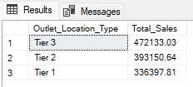

**H. All Metrics by Outlet Type:**

SELECT Outlet_Type,

CAST(SUM(Total_Sales) AS DECIMAL(10,2)) AS Total_Sales,

CAST(AVG(Total_Sales) AS DECIMAL(10,0)) AS Avg_Sales,

COUNT(*) AS No_Of_Items,

CAST(AVG(Rating) AS DECIMAL(10,2)) AS Avg_Rating,

CAST(AVG(Item_Visibility) AS DECIMAL(10,2)) AS Item_Visibility

FROM blinkit_data

GROUP BY Outlet_Type

ORDER BY Total_Sales DESC

